Data Sheet

IP Series Incubators

Features

- PID control with display of actual and set temperature
- Stainless steel radiused interior
- Adjustable shelf positions
- Adjustable vent
- Auto-recovery options
- Class 2 over temperature protection

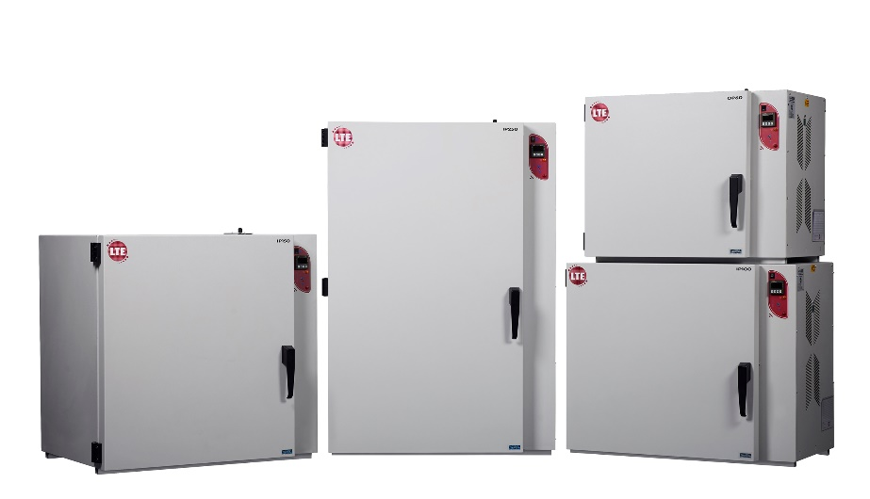

Cat. No. | IP60-U  IP60-UF  IP60-M  IP60-MF | IP100-U  IP100-UF  IP100-M  IP100-MF | IP150-U  IP150-UF  IP150-M  IP150-MF | IP250-U  IP250-UF  IP250-M  IP250-MF
Capacity (litres) | 60 | 100 | 150 | 250
Shelves Included | 2 | 2 | 2 | 3
Temp. Range, ˚C | 30 to 80 | 30 to 80 | 30 to 80 | 30 to 80
Internal Dims, HWD mm | 400 x 400 x 400 | 500 x 500 x 400 | 600 x 500 x 500 | 1000 x 500 x 500
External Dims, HWD mm | 590 x 735 x 575 | 690 x 835 x 575 | 790 x 835 x 675 | 1190 x 835 x 675

The above is the standard specification. Any modification/deviation for the above will be clearly identified on the quotation front sheet

